Make your best Chili join us for the best chili east of the Rockies.

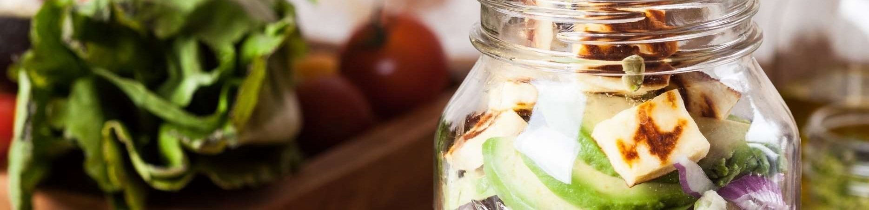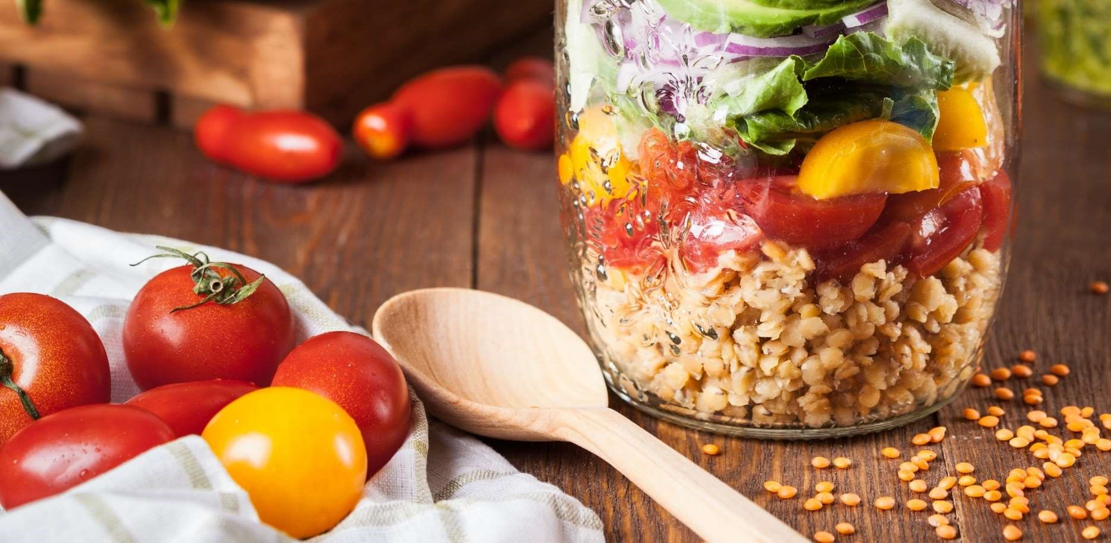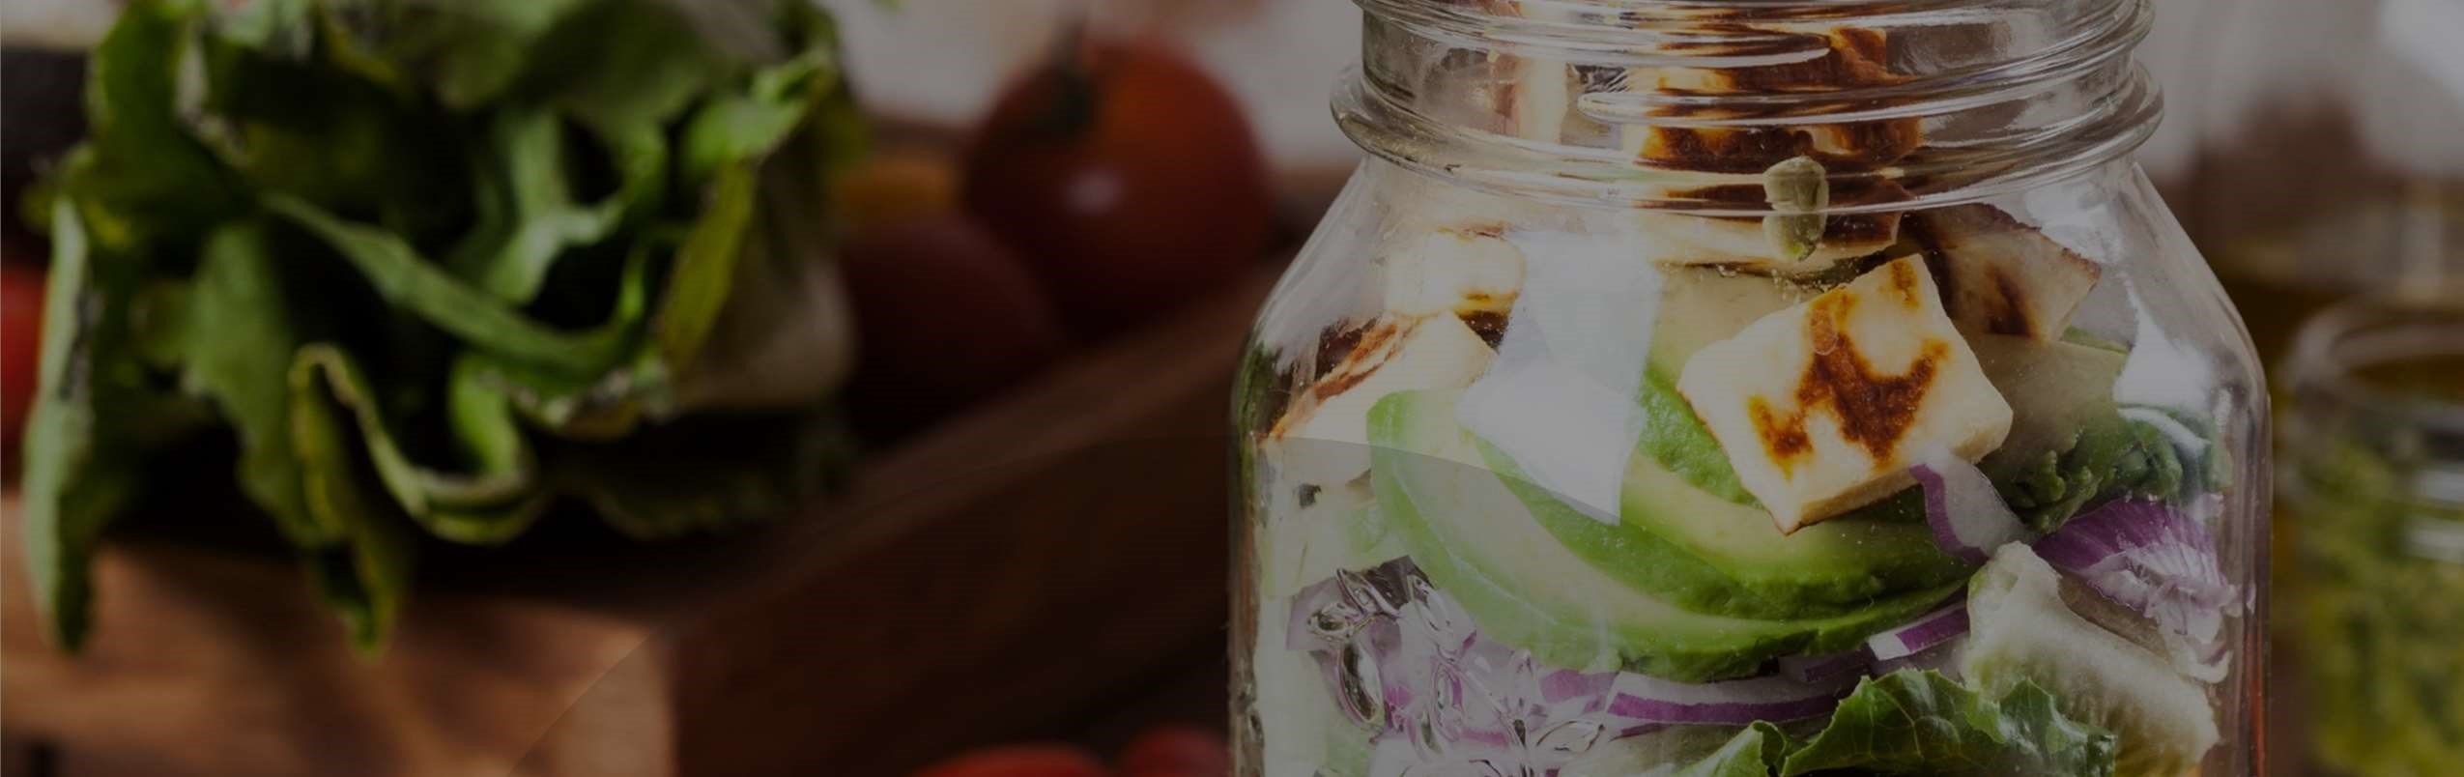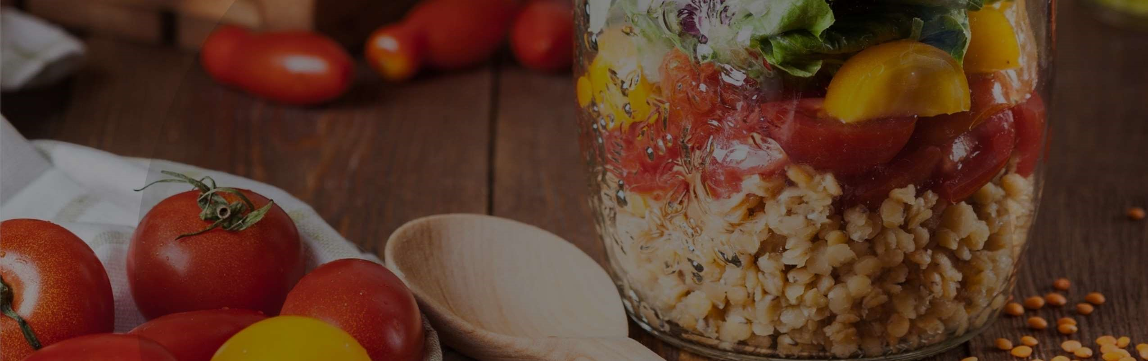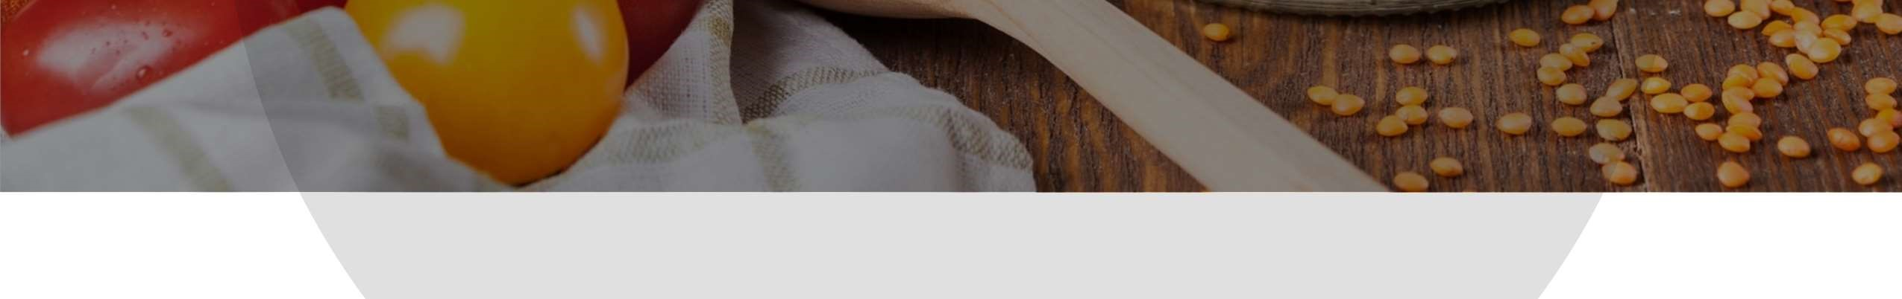

Chili Contest

7

November 17, 2024

1-5

PM

14296

Harpers Run Road

Bealeton VA 22712

50

/50 prize